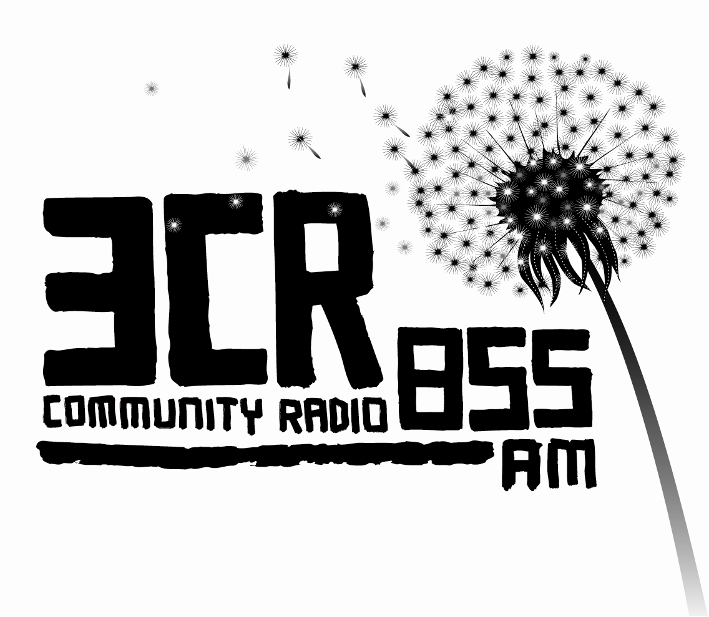
Position Vacant

3CR RADIOTHON WORKER 2013

POSITION DESCRIPTION

Acknowledgement
  - 3CR acknowledges that it broadcasts from land stolen from the Wurundjeri people, the original owners of the land where 3CR is located. The station also acknowledges that it broadcasts to land stolen from other members of the Kulin Nation in Victoria and to land stolen from Aboriginal people throughout Australia.

Fixed Term Position – 200hrs over a period of 11 Weeks (up to 20hrs per week)
Pay rate: $32.03 per hour
Closing Date: 5PM Wednesday 10th April 2013

Position Background
3CR runs an annual Radiothon fundraising appeal to support the financial costs of running the station. Each year we employ a Radiothon worker to support staff and programmers with our fundraising efforts. This years Radiothon runs from 3 June – 16 June 2013, plus Gardening Radiothon on 23rd June.

The Radiothon worker is employed for a fixed-term contract. The successful candidate will start approximately Mon April 24th and finish Friday July 5th 2013. The first weeks will be worked at shorter hours with the time being made up closer to Radiothon week. This will be negotiated with the successful applicant.

Employment conditions are covered by the current 3CR Certified Employment Agreement. Short-listed applicants will be interviewed by a member of the Committee of Management, the Station Manager and a staff member.

Please address the selection criteria in your application.

Duties:
- Motivating, communicating with, and resourcing programmers around Radiothon.
- General coordination of Gardening Radiothon including sourcing donated products, managing sales, rostering and distribution of gardening products
- Contacting individuals and organisations for donations
- Coordination of inserts and adverts in journals/magazines/websites.
- Using online web promotion and social networking tools
- Some coordination of on-air Radiothon programming, including during Radiothon weekend (15th and 16th June).
- Phone answering, pledge taking and general reception duties.
- Station decorating and information
- Attendance at Radiothon staff meetings.
- Other duties as designated by Station Manager

Selection Criteria
Essential
- Demonstrated successful fundraising experience in community based organisation
- Computer literacy including online web promotion tools and Social networking
- Excellent interpersonal communication skills and demonstrated experience working/volunteering in diverse organisation
- Ability to work with minimum direction and supervision.
- Excellent time management skills and demonstrated experience in project coordination
- Ability to work constructively under pressure

Desirable
- Demonstrated understanding of cultural diversity and culturally appropriate organising.
- Demonstrated knowledge and experience of working with culturally and linguistically diverse communities, including Aboriginal and Torres Strait Islander communities.
- Good knowledge of 3CR and community radio.
- Knowledge of a second language other than English

Applications
Please address the Key Selection Criteria in your application.
Applications to be submitted to the Station Manager marked ‘Confidential’.
stationmanager@3cr.org.au or post to PO Box 1277 Collingwood Vic 3066
Closing Date: 5pm Wednesday 10th April 2013

3CR is committed to opposing racism. It supports the integration of cultural and linguistic diversity into the station, including broadcast content, volunteers, staff and management. People from Aboriginal, Torres Strait Islander, and linguistically and culturally diverse backgrounds and people with disabilities are encouraged to apply for employment at the station.

