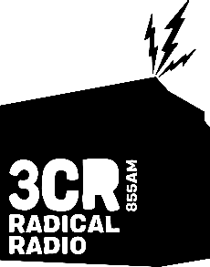
ACCENT OF WOMEN PROJECT
JULY 2024
APPLICATION FORM
Due 5 August 5pm to projects@3cr.org.au

PROJECT BACKGROUND

Accent of Women is a weekly, 30-minute national current affairs program produced at community radio 3CR. In 2024 the program received funding from the Multicultural Media Grants for a dedicated recruitment and training project.

The Accent of Women Outreach project will deliver a dynamic radio training course for up to seven women from culturally diverse, new and emerging communities. The training will be designed and delivered by women from a range of cultural backgrounds and tailored to the needs of the group. Participants will go on to have the opportunity to be regular, paid presenters on this iconic program. Women from diverse cultural backgrounds are marginalised within the wider media landscape, and this project will actively enhance their knowledge, skills and opportunities to have a powerful voice within the media. www.3cr.org.au/accentofwomen

PROJECT DATES, RATES AND REQUIREMENTS

The Accent of Women training will take place on Saturday mornings starting 31 August through to 16 November. Each participant will receive a $600 honorarium at the end of the training course. Participants are required to meet all of the course requirements and have attended at least 75% of the training sessions to be eligible to receive the honorarium.
Applications are open from 15 July to 5 August. Please send through this form and your CV to projects@3cr.org.au before 5pm on Monday 5 August.

The training is in-person at the station in Fitzroy. All women and gender non-conforming people from culturally and linguistically diverse backgrounds are encouraged to apply.

CONTACT DETAILS

Name: Today’s date:
Date of birth: Emergency Name:
Phone: Emergency phone:
Email:
Address:
All station workers at 3CR are required to be current 3CR Subscribers. You can subscribe online, in person, or by calling the station. Are you a current 3CR Subscriber? YES / NO

PROJECT PARTICIPATION

Why do you want to be part of the Accent of Women project and program?

What is your current involvement with 3CR? (current involvement with 3CR is not a pre-requisite)

Please describe any experience you have in producing community media content?

What, if any, is your social justice involvement - either as a volunteer or as an employee?

Please indicate any physical or personal information you would like us to know for your access needs.

Mobility / Hearing / Sight
Communication
Language/Verbal/Written
Allergies/Respiratory/Asthma
Any Medication we should be aware of?
Any other concerns?

